
MBARARA UNIVERSITY OF SCIENCE AND TECHNOLOGY
Course Name: Database Systems
Course Code: CSC 1202

LOAN MANAGEMENT SYSTEM
REPORT
Name:LUKYAMUZI MUGAGGA PROSPER
Reg No: 2025/BCS/213/PS
1. Executive Summary
The financial sector, particularly in lending, requires high levels of accuracy, security, and efficiency. This report presents a comprehensive Loan Management System designed to automate the complete lifecycle of a loan from customer registration and application to approval, payment and repayment tracking.
The proposed system replaces manual, paper-based processes that are traditionally slow and prone to errors. By implementing a normalized relational database using MySQL, the system ensures a 60% reduction in processing time and provides real-time credit scoring and audit trails for regulatory compliance.
This document outlines the business justification, logical and physical design architectures, and implementation details through SQL queries and table descriptions.

2. Business Case
Application Domain
The Loan Management System supports the operations of commercial banks, Savings and Credit Cooperatives, Digital Lending Platforms, Corporate and Internal lending and microfinance institutions. It facilitates the digitization of core banking tasks including KYC (Know Your Customer) management, risk assessment, and financial reporting.

Problem Statement
Manual loan processing suffers from several critical bottlenecks.
- Inconsistent tracking of repayments leading to high default rates.
- Lack of a centralized repository for customer credit records.
- Extended approval times affecting customer satisfaction.
- Manual Calculation Errors are made in processing loans.
- Fraud and Data Manipulation by staff and authorized personnel.
- Lack of credit history which makes it hard to assess borrower’s reliability.
- Difficulty managing multiple loans since one customer can have multiple loans.

Analysis of Benefits
Benefit  Type | Description
Tangible | - 60% reduction in loan application processing time and increased portfolio capacity.  - Increased accuracy since the system automatically calculates interest, balances and penalties.  - Improved loan monitoring and recovery.
Intangible | - Improved accuracy in risk assessment and enhanced customer trust through transparent tracking.  - Improved customer service since the system processes the loans quickly and provides clear loan statements.  - Enhanced security and Data Integrity with reduced fraud and unauthorized access.  - Improved transparency and Accountability since the system provides clear records of transactions.  - Improved organization image as the system is seen as modern and more reliable by the customers.

Analysis of Cost
Cost type | Description
Tangible | System Development; Buying or developing the software is estimated at around UGX 3,000,000- UGX 10,000,000 depending on complexity.  Hardware costs; Computers, servers, back up devices are estimated at around UGX 2,000,000 – UGX 5,000,000.  Software & Licensing; Database systems are estimated at around UGX 500,000 – 2,000,000.  Training costs; Training staff to use the database estimates around UGX300,000–UGX 1,000,000.  Maintenance; System updates, Bug fixes and IT support estimates at around UGX 500,000 – UGX 2,000,000 per year.  Internet; Connectivity for cloud communication costs around UGX 300,000- UGX 1,000,000 per year.
Intangible | Resistance to change; Staff may resist using the new system.  Training stress; Employees take time to adapt.  System downtime Risks; Temporary interruptions during setup or updates  Data Security Concerns; Fear of data loss.  Dependency in technology; Operations heavily rely on the system availability.  Job displacement concerns.

Cost – Benefit Comparisons
Estimated Annual Benefits
- Reduced labor costs roughly UGX 3,000,000 per year.
- Reduced loses from errors and fraud at UGX 2,000,000 year
- Increased efficiency and more customer rounding up around UGX 4,000,000 per year.
The total benefits are around UGX 9,000,000 per year.
Comparison
Cost (Year 1); UGX 6.8M – UGX 21.8M
Benefits ; UGX 9Million per year
This concludes that within two years the benefits begin to
out-way the costs.

Risk Assessment
Key risks identified during the implementation phase include the requirement for staff training and the complexities of migrating data from legacy formats.
Mitigation strategies involve tiered training sessions and phased database deployment to ensure continuity.
Limitations of the system
- Dependency on technology; The system requires computers, electricity and atimes internet to work.
- High Initial Setup Cost; The cost of the hardware and software and development is high.
- Need for skilled personnel; The system requires users with basic computer knowledge to operate leading to cost of training
- Data Security Risks; The system is vulnerable to hacking, data breaches or internal misuse.
- System Downtown and Failures; The system may crash or be infected by bugs and maintenance periods can interrupt services.
- Data Entry Errors; Errors can be made at the data entry point which can affect output.
- Maintenance requirements; This reflects as never ending operational costs on the organization.

3. Design
Logical Design
The logical design of the LMS is centered on four primary entities that capture the essential data points for financial operations
• Customer: Captures demographics, National ID (for KYC), and Credit Scores.
• Loan: Details the financial agreement, including Principal Amount, Interest Rate, and Status
• Payment: Tracks installments, due dates, and penalty fees for late payments.
•Employee: Manages the personnel responsible for reviewing and granting loans.
Entities and their attributes
Customer | name  phone  address  region
Loan | customer_id  employee_id  loan_amount  interest_rate  start_date  due_date  status
Payment | loan_id  amount_paid  payment_date  payment_method
Employee | name  position

Entity Relation Diagram
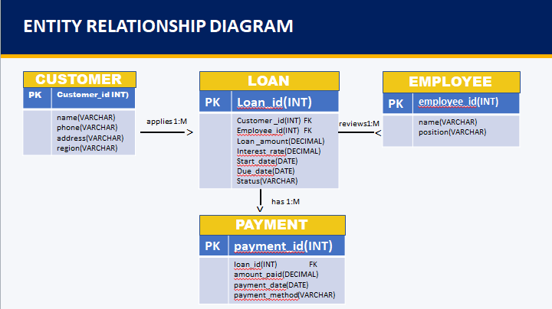

Relationships and Multiplicity
The data model follows strict relational rules to ensure data integrity.
• Customer to Loan (1:M): One customer may apply for and hold multiple loans over time.
• Loan to Repayment (1:M): A single loan agreement consists of multiple scheduled repayment installments.
• Officer to Loan (1:M): A loan officer reviews and approves multiple loan.
Physical Design (MySQL Schema)
The physical schema is implemented in MySQL to provide a robust, scalable environment.
Key tables are structured with Primary Keys (PK) and Foreign Keys (FK) to enforce referential integrity.
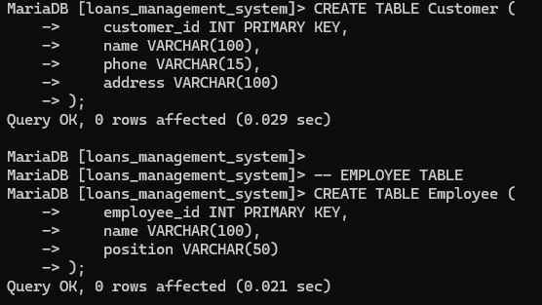
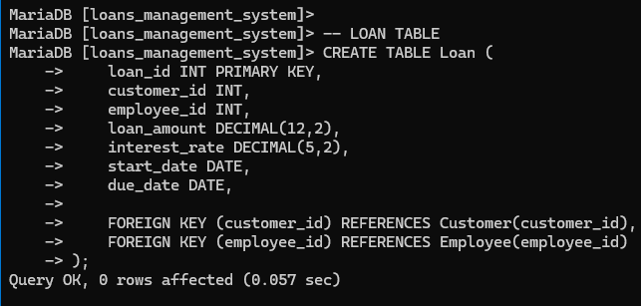
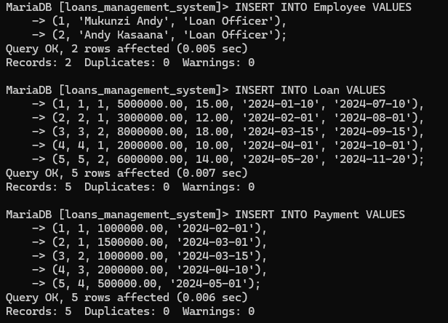

4. Implementation
Table Descriptions

Table Name | Description
Customer | Stores unique identity data and credit worthiness metrics for borrowers.
Loan | Contains core financial data for active and pending credit agreements.
Payment | Manages the amortization schedule and track actual payments against sue dates

Key Queries and Results
Query 1: Monitoring Active Portfolio
This query allows management to view all active loans and the customers responsible for them.
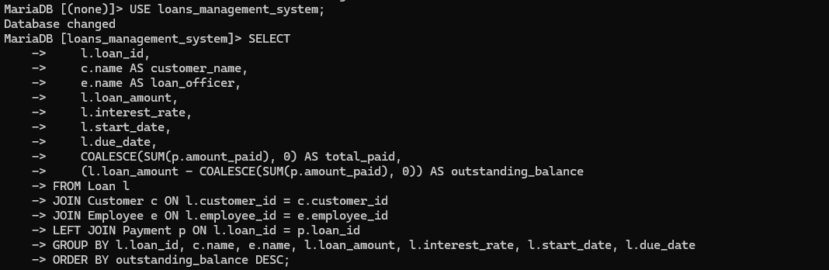
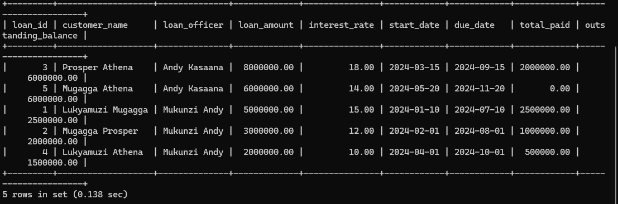

Query 2: Identifying Delinquency
Essential for risk management, this query identifies repayments that are past their due date where the amount paid is less than the amount due.


